Data Visualization

Homework -1

Thirupathi Gandla

1. **Obesity Charts 2005 Vs 2015:**

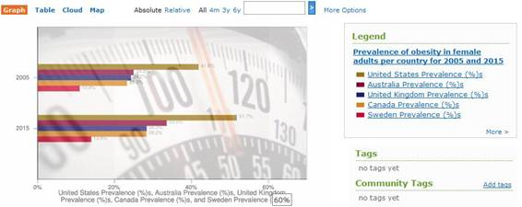

The above visualization is from <https://courses.washington.edu/info424/2007/vizGallery.html#Obesity>.

This representation is attempting to demonstrate the obesity rates of women from 2005 in United States, Australia, United Kingdom, Canada and Sweden and is contrasting those rates and the ones anticipated for 2015. While the correct rates are not known, the author tries to give us a look at what's to come. While much of his efforts to create awareness about obesity should be appreciated, I however discover his diagram lacking to take after some fundamental standards of data visualization.

For a begin, the background of this picture is extremely deceptive and the picture of numbers from the measuring machine would confuse the readers. The intended interest group of this chart would be everyday citizens who should be more mindful of the well-being and this representation would just deceive them.

As said as of now the author does not have the correct esteems for year 2015 and the information spoke to in the diagram is an expectation in view of his work. The graph is highlighting the percentage of obesity prevalence in these five countries.

**Solution:**

I think there are more less demanding and non-complex approaches to speak to these sorts of information. A straightforward bar outline would have been adequate to speak to the prevalence % of all the five nations alongside predicted prevalence percentage. While line charts and area charts additionally would have been exceptional than the one gave by the creator. One vital thing required for the line graphs is to be powerful is the more number of years rather than only two i.e., 2005 and 2015. Instead a series of years such as 2005, 2010 and 2015 would be more visually appealing in case of a line chart.

I suggest to use a simple bar chart comparing the obesity prevalence rates for two years of each country. This way it would give us a clear picture of both reading and comparative ability thus satisfying another important feature of Data Visualization. The bar chart above has a simple back ground and there is no chance for confusion.

**2) Throughput Accounting:**

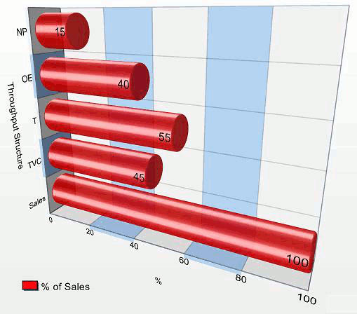

The source for the above visualization is <https://en.wikipedia.org/wiki/Throughput_accounting>.

The above data visualization is utilized to clarify the ideas of Throughput Accounting (TA). Throughput Accounting is a standard based and management Accounting approach that furnishes supervisors with the data for big business benefit change. This chart illustrates a typical throughput structure of income (sales) and expenses (TVC and OE) in 3D. The above perception is attempting to demonstrate the diverse properties of Throughput Accounting and it satisfies cognitive theory.

• Visual Variable Size is observed and it satisfies Selective, Quantitative and Order properties.

Although this portrayal of Throughput Accounting in 3D is great, it can be vastly improved in 2D. His visualization breaks the design principles of Data Visualization as a 3D representation is used where it is not needed and thereby complicating the visualization. As the data, here is comparing the throughput structure on a scale of 100, it is feasible to visualize this data using a bar graph kind of visualization as below.

**Solution:**

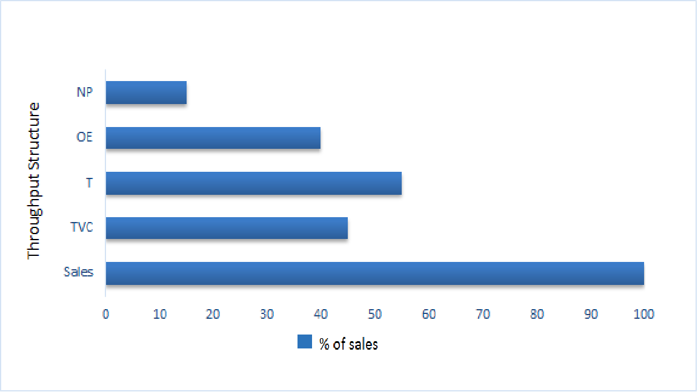

From the above Data Visualization, we can see that the all the Throughput Accounting structure is neatly represented in a 2D graph there by preserving the design principles. This 2D graph is clear and tidy and can be bettered by adding the exact values at end thereby making it easy to read.

**3) Widgets Annual Sales Report:**

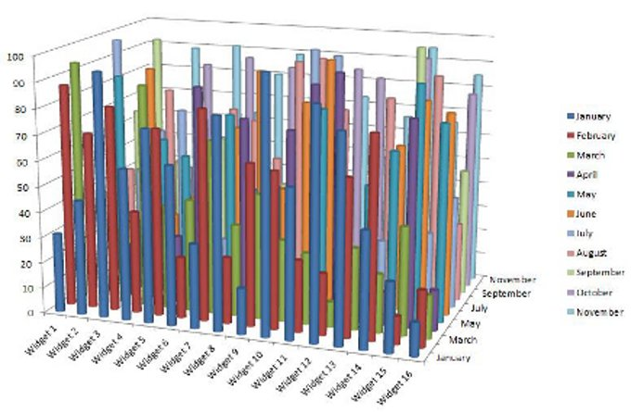

The source of above data visualization is <http://data-visualization-software.com/dangers-of-bling-data-visualizations/>.

The above visualization is a 3D structured presentation intended to show the sales of 16 gadgets for a time of 12 months. Each bar speaking to a gadget's deal for a month. The intended interest group are the corporate individuals who would analyze the sales of their products etc. While speaking to a visual chart in 3D is intriguing and it is inventive to check the third measurement i.e., the months January, February, on a Z – axis.

I should state this information perception is not helpful in at any rate. Although the author prevailing with regards to speaking to every one of the information of the gadgets and their deals in the individual months, it doesn't have the clear picture. A reader could scarcely comprehend the sales of some other month notwithstanding January and to a degree February. Every single other month from March to December are enigmatically noticeable and it is incomprehensible for anybody to influence something important to out of it.

This graph breaks many principles of Data Visualizations. It is neither catchy nor informative. It cannot be used a decision-making tool by the corporate people as it failed to make any comparisons either along time dimension or widget dimension. As it is needed for people to make analysis of all the sales, we can instead go by a line chart. We can use the line chart to represent the sales of all the months per Widget.

**Solution:**

We can make use of line charts like above in order to retrieve more accurate data. To compare them between those 16 widgets we can order them in two rows side by side giving us a whole picture. Another thing which we could do by data aggregating is drawing a line chart for quarterly instead of annual report. This will help us to deduce the sales reports quarterly. Though the result will miss out on minute details. It might be lot better than using a 3D graph.

**4) Anatomy of Winning TED talk:**

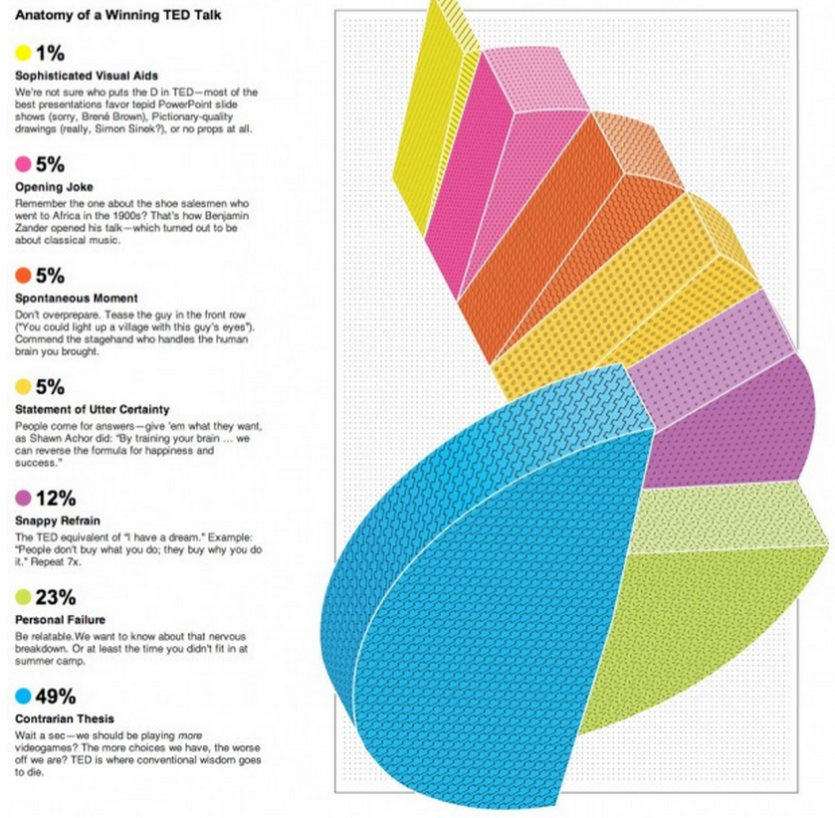

The above visualization is taken from http://blog.visual.ly/.

This Spiral Staircase chart is about the structures of TED syndicated program. It is an overall prevalent show where it has pulled in US presidents, Nobel Prize champs, and so forth to their speaker arrangement. TED talks have turned into a stage for the eager speakers who can let the world think about their skill in a field. In this way, this representation is for those trying toastmasters to enable them to make the best utilization of their chance in the spotlight.

* Visual Variable Position is observed and it satisfies Selective, Associative, Order characteristics.
* Visual Variable Size is observed and it satisfies Selective, Associative, Order characteristics.
* Visual Variable Shape is observed and it satisfies Selective, Associative characteristics.
* Visual variable color is observed and it satisfies Selective, Associative characteristics.

Firstly, the above perception is spoken to in 3D with no reason. The utilization of 3D for the most part doesn't bode well and doesn't fuse any importance to the outline. Moreover, it makes the information vague. A superior representation approach is to demonstrate just the imperative points of interest. Furthermore, we see that a lot of information is shown making the graph untidy. Wide depictions of information are not favored in perceptions. At last, this winding graph is ineffectual because it expects us to coordinate the slice colors to the little shaded circles that is available to one side of the chart. In this way, this chat is tedious which requires pointless work that is moving forward and backward to coordinate the percentage and the pie slice colors.

**Solution:**

This data can be better represented with the help of a pie chart. The reason why a simple pie chart is more preferred to a 3D spiral is straightforward, it does not break the design principle of data visualization. The design principle states that the 3D modelling is not encouraged when it is not needed especially if it can be clearly done on a simpler basis. The pie chart is apt for representing this type of data because the number of partitions are less and can be easily visualized on a pie chart. Also, when we compare the color code which is given on the left side of the spiral chart, it is time consuming for the users. On the other hand, this pie chart is an easy way of showcasing data as it has the data labels intact to the model.